
St. Clair College

Data Analytics for Business

DAB422-24W-001 CAPSTONE PROJECT 2 Winter 2024 - 001

Enhancing Emergency Room Efficiency

Group 10
Eduardo Chavez Barrientos – 0828349
Noushin Adsadsamani – 0829532
Jerusha Sheba Maben– 0825449
Pearlin Ronald Pereira– 0815060

Guided By,
Prof. Abiodun Sodiq Shofoluwe

Acknowledgments

We would like to express our profound gratitude to Professors Abiodun Sodiq Shofoluwe and John Ulakovich for their invaluable assistance in this project. Their expertise and guidance have been instrumental in helping us navigate the complexities of healthcare systems and reach out to relevant institutions. We appreciate their unwavering support and collaboration throughout this project. Despite the challenging situation we faced through the data gathering, it highlighted the resilience and adaptability of our team. We were able to swiftly respond, adapt, and continue our work, turning a potential setback into an opportunity for learning and growth, thanks to the guidance and support from Professors John and Abiodun Sodiq Shofoluwe. Once again, we extend our heartfelt thanks to Professors John and Abiodun Sodiq Shofoluwe for their contributions. Their insights and expertise have greatly enriched this project, and we look forward to future collaborations.

Abstract

This project aimed to predict and understand real wait times experienced by patients in hospital settings. Our approach involves developing a predictive model that accurately calculates wait times by analyzing crucial data points, particularly the time lapse between patient admission and nurse attendance. By zeroing in on this pivotal aspect of patient experience, our objective is to furnish comprehensive insights into the determinants of wait times and subsequently propose targeted strategies for enhancement.

This shift in focus underscores our commitment to analyzing historical data, with a particular emphasis on delineating the interval between patient arrival and admission. Our overarching objective is to bolster the efficacy of healthcare provision by identifying discernible patterns, resolving bottlenecks, and uncovering opportunities for process optimization. Through a thorough examination of wait time dynamics, we aspire to offer actionable recommendations to mitigate delays, alleviate overcrowding, and optimize the overall patient care landscape within the hospital's Emergency Department.

Introduction

The Emergency Department (ED) stands as a critical pillar of healthcare, serving as the primary point of entry for a diverse array of patients with varying medical needs. Operating within resource constraints, with human attention being a particularly precious commodity, effective allocation becomes paramount to maximize positive patient outcomes. Recent strides in algorithmic approaches offer promising avenues for elevating the quality of care provided within the ED.

In the face of significant challenges such as patient care delays, prolonged waiting times, and overcrowding, the ED grapples with the intricate balance of managing urgent cases while delivering timely care for less severe conditions. These challenges are further compounded by resource limitations, including medical personnel and equipment. Addressing these complexities necessitates meticulous coordination and resource optimization.

Our primary objective in this project is to enhance ED operations by predicting patient wait times through the analysis of data sourced from the MIMIC-IV database, originating from a Boston-area tertiary academic medical center. By scrutinizing and leveraging the wealth of data available, we aim to develop predictive models that estimate wait times by subtracting the duration between a nurse's initial patient check and the patient's entry into the hospital. This approach enables us to understand and anticipate wait times and devise strategies for enhancing patient care, optimizing resource allocation, and fostering a more efficient and responsive emergency care environment within the ED.

Dataset Description

MIMIC-IV is a relational database containing real hospital stays for patients admitted to a tertiary academic medical center in Boston, MA, USA. MIMIC-IV contains comprehensive information for each patient while they were in the hospital: laboratory measurements, medications administered, vital signs documented, and so on. MIMIC-IV is separated into “modules” to reflect the provenance of the data. There are currently five modules: “hosp” - hospital level data for patients: labs, micro, and electronic medication administration; “icu” - ICU level data. These are the event tables and are identical in structure to MIMIC-III (chartevents, etc); “ed” - data from the emergency department; “cxr” - lookup tables and meta-data from MIMIC-CXR, allowing linking to MIMIC-IV; “note” - deidentified free-text clinical notes. For this Project we stick into the “ed” module that contains data for emergency department patients collected while they are in the ED. Information includes reason for admission, triage assessment, vital signs, and medicine reconciliation.

In this study, we integrated six relational datasets into a unified dataset. Each dataset represented distinct aspects of our data such as: real-time patient tracking, medicine reconciliation, diagnoses management, Pyxis system, triage system, vital signs monitoring.

Table 1: The diagnosis table records the diagnosed conditions of patients treated in the emergency department.
Table 2: the "edstays" table, tracks the time patients arrived at and left the emergency department.
Table 3: The "medrecon" table stores the medications reported by patients upon admission to the emergency department, a process known as medicine reconciliation.
Table 4: The "pyxis" table contains data about medication dispensations facilitated through the Pyxis system.
Table 5: The "triage" table stores data on patients' initial assessments upon arrival in the emergency department, including vital signs, acuity levels, and prioritization for care.
Table 6: The vital sign table records patients admitted to the emergency department that have routine vital signs taken every 1-4 hours.

By merging these datasets, we consolidated the information into a single cohesive dataset. This merging process involved identifying common fields between the datasets and combining them using appropriate join operations. The resulting merged dataset provides a comprehensive view of our data, enabling us to perform in-depth analysis and gain insights across multiple dimensions.

Data Pre-Processing

The dataset under consideration consists of six interconnected tables, with each table sharing common identifiers linked by the 'subject_id', serving as the primary key. To facilitate analysis and insights, the initial step in our data preprocessing involved merging these tables into a cohesive dataset, utilizing 'subject_id' as the primary key. This consolidation provided a unified perspective, simplifying data examination and interpretation.

Following the consolidation, our subsequent data preprocessing phase focused on identifying and addressing duplicate entries and null values within the dataset. Duplicate entries possess the potential to distort analysis outcomes, while null values can introduce errors into predictive models. Thus, it was imperative to detect and rectify these issues at an early stage. Various data cleaning techniques were deployed for this purpose. Duplicate entries were systematically removed to ensure dataset integrity, guaranteeing each record's uniqueness. Columns containing missing values exceeding 5% were filled by substituting them with the mean value of their respective columns (such as Temperature VS, o2sat vs, resprate VS). Pain Vs values were filled using the mode. We opted to remove the 'rhythm' column due to its high occurrence of null values (95%) and its categorical nature, which would have necessitated inappropriate data manipulation if filled with the mode. Adhering to the rule of thumb for handling null values, which suggests dropping them if they are less than 5%, we evaluated the percentage of missing values in each column.

Our main aim was to find the wait time and to do this we had to subtract the Chart time and in time. We created a new column – wait time to find the difference between the two and use it as our target variable. By doing this we find that the minimum wait time for patients is 14 minutes, and the maximum wait time goes up to 866 minutes which is approximately about 14 hours.

Visualization

Distribution of waiting time in ER
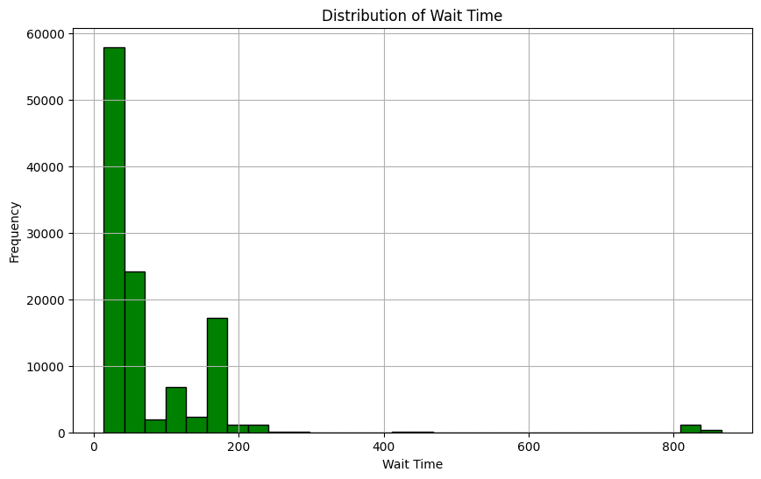
The visualization depicts the distribution of wait times in an emergency room setting. Most patients experience short waits of 0-30 minutes, likely due to quick triage and efficient care. There are also moderate waits of 30-200 minutes, mainly for non-life-threatening but still serious cases. Longer waits of 400-800 minutes are rare and usually avoided, as they can worsen patients' conditions. However, they might occur during high volume or staffing shortages. Overall, the data shows the balance between swift care and managing more severe cases in emergency healthcare.

Patient Stay Durations
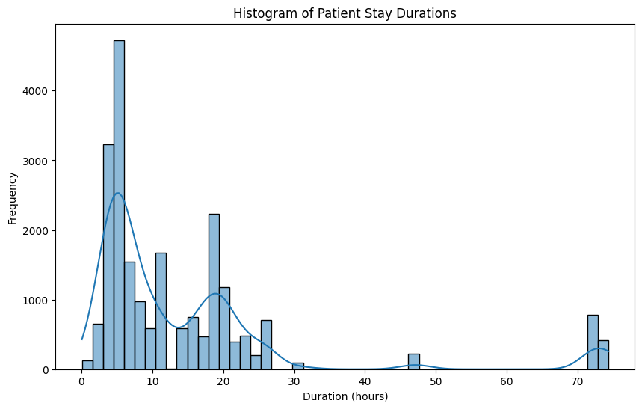
The visualization highlights a prominent peak at approximately 5 hours, indicating that this duration is typical for patient stays in the examined dataset. This suggests that the majority of patients spend around 5 hours in the facility before being discharged or transferred. Additionally, smaller peaks are observed around 20 hours, suggesting that this duration is also relatively common, albeit less frequent than the 5-hour mark. Beyond 70 hours, there is a notable decrease in the frequency of patient stays, indicating that longer durations are less common. This trend may be attributed to the fact that extended stays are often associated with more complex or severe health issues, which occur less frequently in the dataset.

Number of subjects by Race and Sex

The depicted graph illustrates a notable disparity in the number of casualties between genders, with men exhibiting a higher incidence compared to women. Among men admitted to the Emergency Room (ER), individuals of white ethnicity constituted the majority, followed by those from other racial and ethnic backgrounds. Conversely, within the female demographic, white women emerged as the most frequently admitted group, followed by Black/African women and Hispanic/Latino - Salvadorian women. Of particular interest is the observation that Hispanic/Latino - Cuban women accounted for the lowest frequency of ER visits among all groups analyzed. This nuanced breakdown underscores the intersectionality of gender and race/ethnicity in emergency healthcare utilization patterns, prompting further inquiry into the underlying determinants and healthcare disparities within these demographic segments.

Mode of arrival

An analysis of the mode of arrival reveals that the predominant method for patients reaching the Emergency Room (ER) was via ambulance, constituting the highest proportion among all arrival modes. Following ambulance arrivals, walk-ins and other unspecified modes of arrival were also observed, though to a lesser extent. Interestingly, a gender-based examination of arrival methods indicates that women exhibited a slightly higher propensity than men to arrive by ambulance. Furthermore, women constituted a larger proportion of walk-in patients compared to men, suggesting potential differences in healthcare-seeking behaviors or healthcare needs between genders within the ER context. This nuanced understanding of arrival patterns underscores the importance of tailored approaches in emergency healthcare provision to accommodate diverse patient demographics and preferences effectively.

Complaints and Symptoms

The analysis of the word cloud highlights prevalent reasons for Emergency Room (ER) admissions, with a notable emphasis on patients either being transferred from another hospital or admitted due to chest pain, emerging as the most frequently encountered conditions. Following closely behind, hyperglycemia and overdosage ranked as the second most common causes of ER admissions, reflecting the diverse range of medical concerns addressed within the ER setting. Conversely, abnormalities in test results and instances of hematemesis were identified as relatively infrequent reasons for ER admissions. This insight into the distribution of admission reasons underscores the spectrum of medical conditions encountered in the ER, guiding healthcare professionals in prioritizing resources and interventions to address the diverse needs of patients presenting to the emergency department.

Machine Learning

In order to proceed with predictive analysis using machine learning technology, several factors requiring modification were identified beforehand.

Feature Engineering:
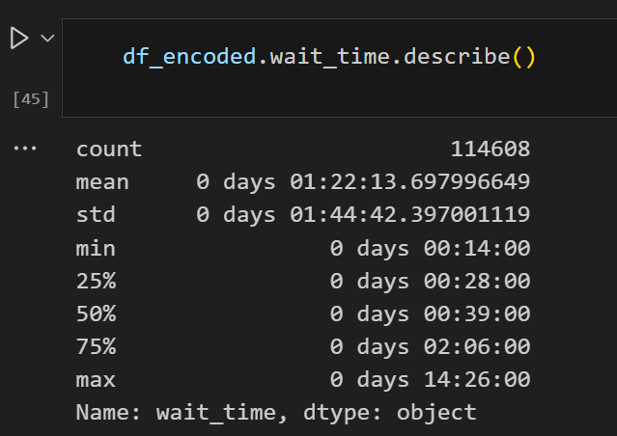
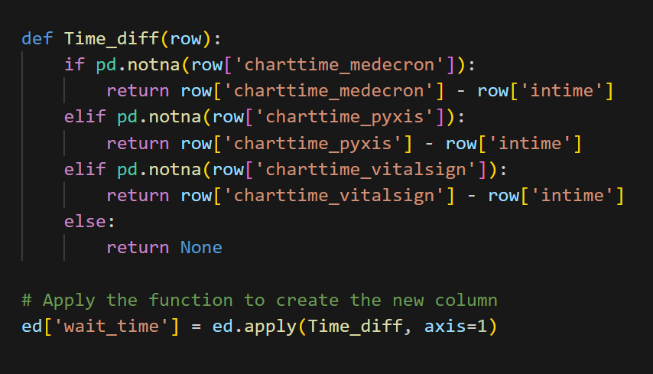

Within our project, the term "Chart Time" refers to the duration during which nurses attend to patients and conduct the initial triage process. Understanding the time patients spend waiting is essential for our analysis. To obtain this information, we introduced a new metric known as "Wait Time," calculated by subtracting the "Chart Time" from the "In Time." This innovative approach allowed us to derive valuable insights into patient waiting durations.

Upon analyzing the data, we observed that the wait times varied significantly. The shortest wait time recorded was a mere 14 minutes, while the longest stretched to an astonishing 866 minutes, equivalent to approximately 14 hours. These findings shed light on the patient experience within our healthcare system and served as a critical component of our feature engineering process, enhancing the depth and accuracy of our analysis.

Encoding:

In our data preprocessing phase, we employed various encoding techniques tailored to the nature of the features within our dataset, which comprised approximately 38 columns.
For nominal features, where categories hold no inherent order, we implemented a Count Encoder. This method replaces each category with the count of its occurrences in the dataset. By adopting this approach, we aimed to capture the frequency distribution of each category, providing valuable insights into their prevalence within the data.

In contrast, ordinal features possess a clear order or hierarchy among their categories, exemplified by attributes like "seq_num" and "acuity." To encode these features, we opted for an Ordinal Encoder. This encoder assigns a numerical value to each category based on its position in the predefined order or hierarchy, facilitating the preservation of the inherent structure within the data.
Lastly, for boolean features representing binary states, such as "icd_version" and "gender," we utilized a One-Hot Encoder. This encoding method creates binary columns for each category, effectively transforming them into numerical representations. By doing so, we could capture the presence or absence of specific attributes while maintaining the integrity of the original data.

Overall, our encoding strategy was designed to streamline the dataset and enhance its manageability without compromising on the richness of the information it contains. This meticulous approach ensured that our dataset remained conducive to in-depth analysis, paving the way for meaningful insights and discoveries.

Correlation Matrix:

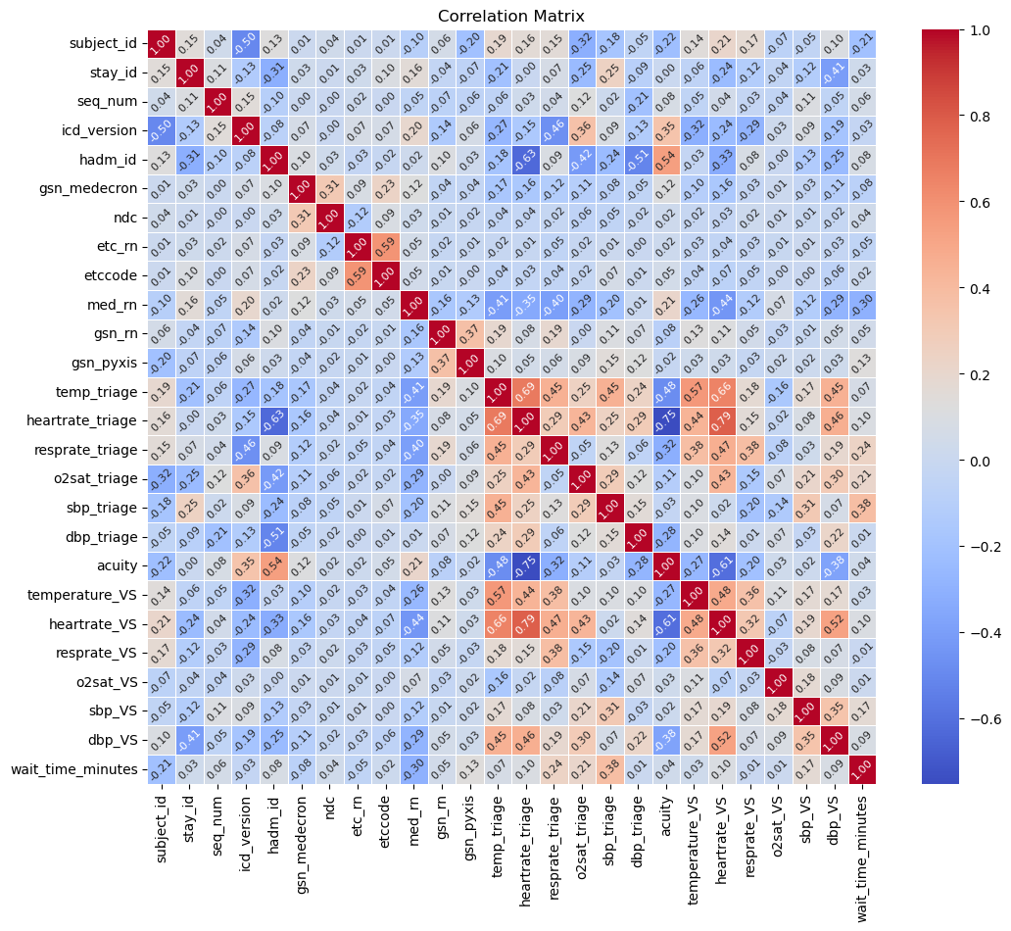

After conducting a comprehensive analysis of our correlation matrix, we identified several features that exhibit notable correlations with the target variable, "wait time." Specifically, attributes such as "med_rn," "respiratory rate triage," "oxygen saturation triage," and "systolic blood pressure triage" demonstrated discernible correlations with the target variable.

With these insights in mind, we made a strategic decision to focus our modeling efforts on a subset of variables that demonstrated a significant correlation with the target variable. By selecting these specific features, we aimed to streamline our model and explore the potential impact of leveraging only those attributes that exhibit a meaningful relationship with the target variable.

This targeted approach allows us to conduct a more focused analysis, enabling us to assess the predictive power of variables that have demonstrated a propensity to influence our target variable, "wait time." Through this iterative process, we anticipate gaining deeper insights into the underlying relationships within our dataset and optimizing the performance of our predictive model.

Model 1:
In the initial phase of our machine learning model development, we strategically focused on a subset of features identified through rigorous analysis of the correlation matrix. These features, namely "respiratory rate triage," "oxygen saturation triage," "systolic blood pressure triage," and "medication administered by registered nurse (med_rn)," were selected based on their substantial correlations with the target variable.

Employing the AdaBoost Regressor algorithm, we constructed our inaugural predictive model utilizing this refined set of features. The evaluation of this model revealed promising performance metrics: Mean Squared Error (MSE) of 741.15, R-squared Score of 0.935, and Mean Absolute Error (MAE) of 15.77.

Subsequently, we embarked on a meticulous optimization process using Grid Search CV to fine-tune the parameters of our AdaBoost Regressor model. Through this iterative approach, we identified the optimal parameter configuration, including 'base_estimator_max_depth': 8, 'learning_rate': 1.0, and 'n_estimators': 100. Leveraging these optimized parameters, we conducted a comprehensive evaluation of the model's performance, resulting in notable improvements in performance metrics, with a reduced MSE of 313.33 and a diminished MAE of 7.17.

This meticulous parameter tuning process underscores our commitment to enhancing the predictive capabilities of our model and optimizing its performance. The significant performance enhancements achieved through parameter optimization validate the effectiveness of our approach and underscore the potential for further refinement and advancement in our predictive modeling endeavors.

Model 2:
Our next modeling iteration encompassed all features within our dataset, utilizing them to train an AdaBoost Regressor model. The evaluation of this comprehensive model yielded the following performance metrics: Mean Squared Error: 876.56; Mean Absolute Error: 19.96; R-squared Score: 0.923.

Feature Selection:
Subsequent to feature selection, we retained features with importance percentages exceeding 5.0. The selected features and their corresponding importance percentages are as follows:
sbp_triage: 15.9%, chiefcomplaint: 14.6%, dbp_triage: 12.0%, disposition: 11.8%, ndc: 11.1%, pain_triage: 8.6%, temp_triage: 6.5%.

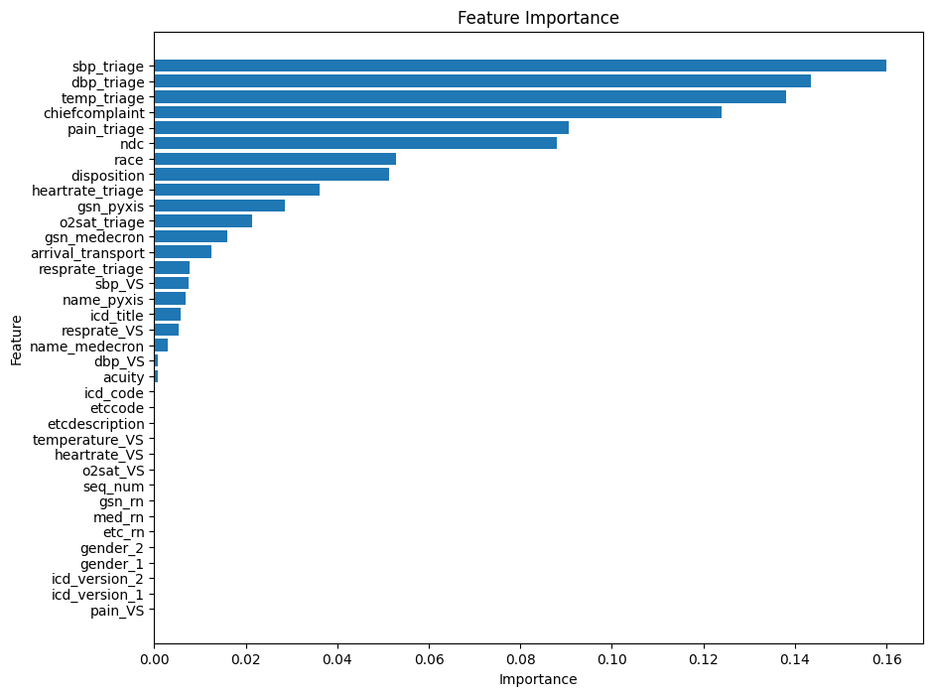

Utilizing this refined feature set, we constructed a new dataset and trained our third AdaBoost model. The performance metrics of this model are as follows: Mean Squared Error: 829.93; Mean Absolute Error: 19.20; R-squared Score: 0.927.

Hyper Param Tuning (Grid Search CV):
Employing grid search cross-validation, we fine-tuned the hyperparameters for our model trained on the selected features obtained from feature selection. The optimized model yielded the following performance metrics: Mean Squared Error: 56.28; Mean Absolute Error: 1.81; R-squared Score: 0.995. These results represent the evaluation outcomes of our model after hyperparameter tuning using grid search cross-validation.

Findings

The Mean Squared Error (MSE) value of 56.28 serves as a pivotal indicator, representing the average squared disparity between the predicted and actual wait times within the emergency room dataset. A lower MSE signifies that the model's predictions closely align with the observed values, a desirable trait in predictive modeling endeavors.

Furthermore, the Mean Absolute Error (MAE) stands impressively low at 1.81, underscoring the model's remarkable accuracy in estimating wait times. This metric signifies the average absolute deviation between the predicted and actual wait times, with deviations of merely 1.81 minutes on average.

Notably, the R-squared Score (R2) attains a remarkable value of 0.995, indicating that our model adeptly explains approximately 99.5% of the variance observed in the wait time data. This exceptional R-squared score underscores the model's robust fit to the dataset, affirming its capability to deliver highly precise predictions with a profound understanding of the underlying data dynamics..

Deployment

Model Serialization:
To ensure seamless integration and efficient inference, our trained machine learning model has been serialized using the Pickle technology. Serialization allows us to convert the model into a portable format (model.pkl), enabling quick loading and utilization without the need for retraining. This approach enhances the scalability and performance of our model deployment process.

Web Application Deployment (Framework: Flask):
Our model is deployed within a web application framework built on Flask, a lightweight and versatile Python web framework. This deployment strategy enables user interaction through intuitive web forms, facilitating data input for prediction purposes. The main features of our web application include: chiefcomplaint, dbp_triage, pain_triage, sbp_triage, temp_triage, ndc, o2sat_triage, disposition, race.

Here is a breakdown of our python script (app.ipynb) :

- Libraries: It begins by importing necessary libraries including Flask for web development, NumPy for numerical computations, and pickle for loading a trained machine learning model.
- Loading Model: The trained machine learning model is loaded using pickle.
- Flask App Setup: An instance of the Flask class is created.
- Routes: '/': This is the root route, rendering an HTML template (index.html) for user input.
'/predict': This route is triggered when the form is submitted. It retrieves input data,
preprocesses it, predicts the wait time using the loaded model, and renders the result on the same HTML template.
- Error Handling: In case of any exceptions during prediction, an error template (error.html) is rendered with a descriptive message.
For example; Suppose we enter string values in the fields, it automatically directs us to the error page displaying the reason for the error.

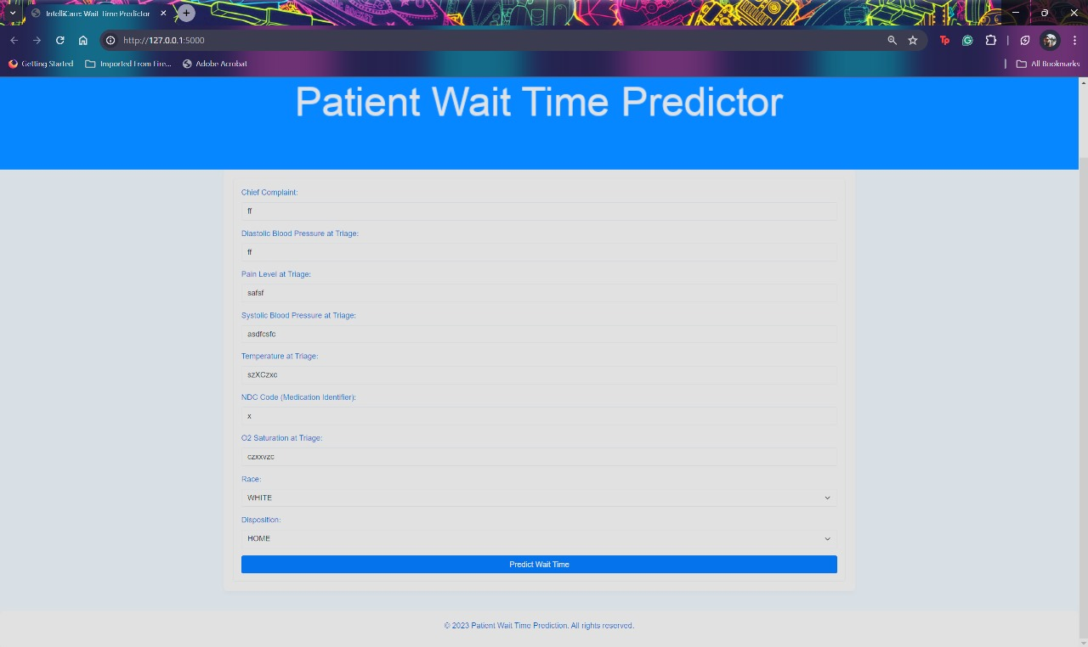

Error.html

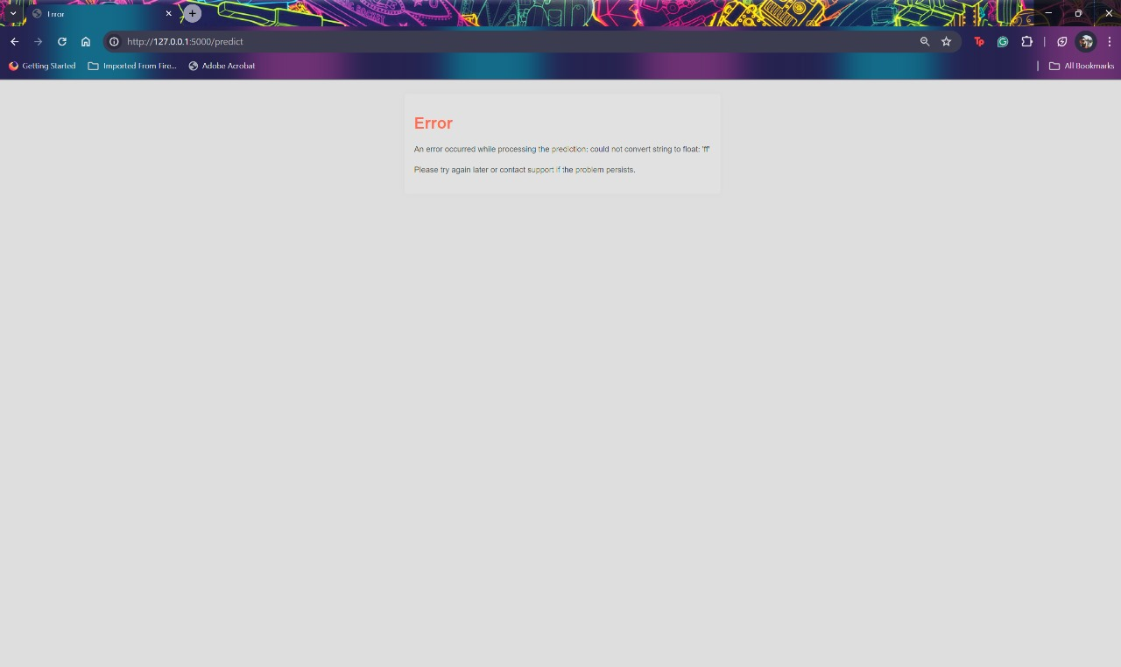

- Server Execution: The Flask application is run with app.run().

Model Integration: The serialized model is seamlessly integrated into the Flask framework, enabling efficient handling of web requests and prediction tasks.
User Interaction: Users can interact with the application through a user-friendly interface provided by web forms, simplifying the process of inputting data for prediction.
Prediction Results: Upon submission of data through the web form, the application processes the input and provides prediction results to the user in a clear and understandable format.

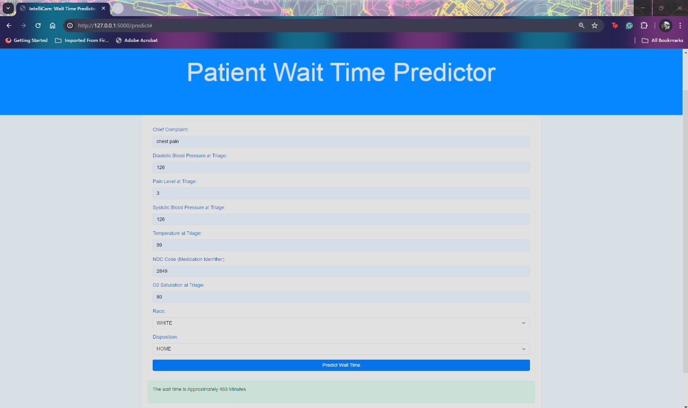

Recommendations

Pre-arrival Information: Gather patient information (like chief complaint, pain level) before they arrive at the ED. This could be done through emergency medical services (EMS) in the field. This allows the ED to prepare resources and personnel in advance.
Predictive Modeling: Use the ML model to predict patient flow and waiting times based on real-time data. This can help manage resources more effectively and reduce waiting times.
Risk Stratification: The ML model can be used to stratify patients based on risk levels. Patients with higher risk (based on blood pressure, chief complaint, pain, temperature) can be attended to more quickly.
Continuous Monitoring and Improvement: Continually monitor and analyze patient data to identify trends, bottlenecks, and areas for improvement. This should be an ongoing process, as factors affecting ED wait times can change over time.
Model Improvement: Continuously feed the model with new data to improve its predictive accuracy. Regularly evaluate and update the model to ensure it reflects the most current trends and patterns.
Decision Support: Use the ML model as a decision support tool for healthcare professionals in the ED. The model can provide data-driven insights to assist healthcare professionals in making quick decisions.

Conclusion

The incorporation of Machine Learning models within emergency department operations holds significant promise for enhancing waiting times. It is imperative to acknowledge, however, that while these sophisticated tools offer invaluable insights and predictive capabilities, their role is complementary to established healthcare protocols and the expertise of medical professionals.

Ensuring the sustained accuracy and applicability of any Machine Learning model necessitates ongoing evaluation and refinement. Regular assessment and updates are indispensable to uphold the model's effectiveness amidst evolving healthcare dynamics.

Moreover, the ethical implications surrounding the deployment of such technologies, alongside paramount concerns pertaining to patient privacy and data security, must remain paramount throughout the implementation process. Prioritizing these ethical considerations underscores the commitment to leveraging technology responsibly and ethically within the healthcare domain.

References

Siddiqui, A. (2022, November 12). ML-MODEL-DEPLOYMENT-USING-FLASK. GitHub. https://github.com/siddiquiamir/ML-MODEL-DEPLOYMENT-USING-FLASK

Kadri, F., Dairi, A., Harrou, F., & Sun, Y. (2022). Towards accurate prediction of patient length of stay at emergency department: a GAN-driven deep learning framework. Journal of Ambient Intelligence and Humanized Computing. https://doi.org/10.1007/s12652-022-03717-z

Saini, A. (2021, September 15). AdaBoost Algorithm - A Complete Guide for Beginners. Analytics Vidhya. https://www.analyticsvidhya.com/blog/2021/09/adaboost-algorithm-a-complete-guide-for-beginners/

Saxena, S. (2020, August 13). Here’s All you Need to Know About Encoding Categorical Data (with Python code). Analytics Vidhya. https://www.analyticsvidhya.com/blog/2020/08/types-of-categorical-data-encoding/

Working with Missing Data in Pandas. (2019, January 3). GeeksforGeeks. https://www.geeksforgeeks.org/working-with-missing-data-in-pandas/

Advance ER. (2016, May 12). 7 Reasons for Long ER Wait Times at Hospitals. Advance ER. https://www.advanceer.com/resources/blog/2016/may/7-reasons-for-long-er-wait-times-at-hospitals/
‌

‌

‌

‌

‌

‌

